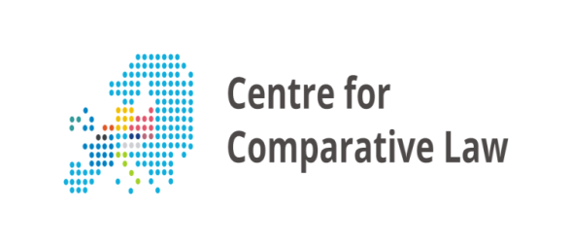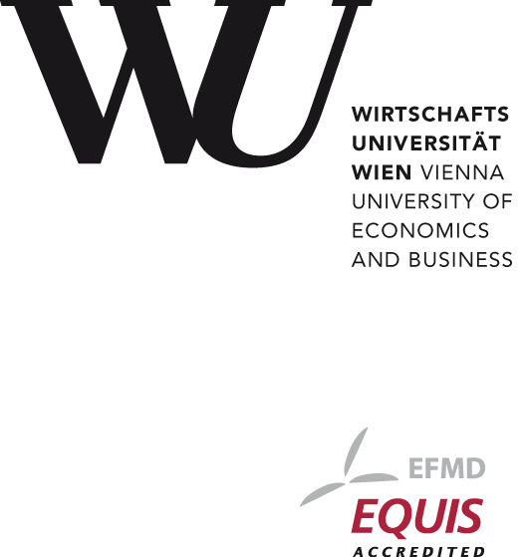

**Conference on Abuse of Law**

**October 20 and 21, 2016**

Budova PF UK, Praha 1, nám. Curieových 7, místnost č. 38, přízemí

**Program**

**Thursday, October 20**

9.45 Welcoming and introductory remarks

**Session I: Foundations**

10.00 *The Structure of the Abuse of Law*

Michael Potacs, Vienna University of Economics and Business

10.30 *Abuse of Law and its Consequences*

Luboš Tichý, Charles University Prague

11.00 *Prohibition of Abuse of Law as a Legal Principal*

Slavomíra Henčeková, Charles University Prague

11.30 *Discussion*

12.00 Lunch for the speakers

**Session II: Private Law**

13.30 *Abuse of Rights in Civil Law*

Georg Kodek, Vienna University of Economics and Business

14.00 *Abuse of Corporate Law*

Friedrich Rüffler/Julia Told, University of Vienna

14.30 *Abuse of Labour Law*

Martin Risak, University of Vienna

15.00 *Abuse of Rights in the Czech Labor Law*

Petr Hůrka, Charles University Prague

15.30 *Discussion*

16.00 Coffee Break

16.30 *Abuse of Property and similar Rights in Competition Law*

Petra Pipková, Charles University Prague

17.00 *Abuse of Principle of Creditor´Autonomy in the insolvency proceedings*

Tomáš Troup, Charles University Prague/Andreas Frössel, Vienna University of Business and Economics

17.30 *Determination of Governing Law as a Tool of Abuse of Law in Cases of Liability for Damage*

Jiří Hrádek, Charles University Prague

18.00 *Discussion*

18.30 End of the first day of the conference

**Friday, 21 October**

**Session III: Public Law**

9.30 *Abuse of Law and Abuse of Administrative Discretion – the Czech View*

Richard Pomahač /Jakub Handrlica, Charles University Prague

10.00 *Abuse of Law and Abuse of Administrative Discretion – the Austrian View*

Claudia Fuchs, Vienna University of Business and Economics

10.30 *Abuse of Tax Law*

Petra Kamínková, Charles University Prague/Markus Seiler, Vienna University of Business and Economics

11.00 *Discussion*

12.00 Lunch for the speakers

**Session IV: Human Rights, International and EU-Law**

13.30 *Abuse of Law as a General Principle in Union Law*

Claudia Wutscher, Vienna University of Business and Economics

14.00 *National Practises of Abuse of Social Assistance by European Union Citizens on the Move*

Solange Maslowski, Charles University Prague

14.30 *Discussion*

15.00 Coffee Break

15.30 *Abuse of Human Rights*

Christoph Bezemek, University of Graz

16.00 *Abuse of Rights in International Law*

Erich Vranes, Vienna University of Business and Economics

16.30 *Discussion*

17.00 End of the conference

**No charge.**

**Further information: novackov@prf.cuni.cz**